giadinhtiendung Website

**Software Development Plan (Small Project)**

**Version** 0.1

**Revision History**

| **Date** | **Version** | **Description** | **Author** |
| --- | --- | --- | --- |
| 04/10/2023 | 0.1 | Contains certain information about the project initial requirement | Group 04 |
|  |  |  |  |
|  |  |  |  |
|  |  |  |  |

**Table of Contents**

**1.** **Introduction 4**

*1.1* *Purpose 4*

*1.2* *Scope 4*

*1.3* *Overview 4*

**2.** **Project Overview 4**

*2.1* *Project Purpose, Scope, and Objectives 4*

*2.2* *Assumptions and Constraints 4*

*2.3* *Project Deliverables 5*

**3.** **Project Organization 5**

*3.1* *Organizational Structure 5*

*3.2* *Roles and Responsibilities 5*

**4.** **Management Process 5**

*4.1* *Project Estimates 5*

*4.2* *Project Plan 5*

4.2.1 Phase Plan 5

4.2.2 Iteration Objectives 6

4.2.3 Releases 6

4.2.4 Project Schedule 6

4.2.5 Project Resourcing 6

*4.3* *Project Monitoring and Control 6*

4.3.1 Requirements Management 6

4.3.2 Reporting and Measurement 7

4.3.3 Risk Management 7

4.3.4 Configuration Management 7

**Software Development Plan (Small Project)**

# **Introduction**

The introduction of the Software Development Plan provides an overview of the entire document. It includes the purpose, scope, references, and overview of this Software Development Plan.

The purpose of this document is to define high-level features of the giadinhtiendung e-commerce website. It focuses on the capabilities needed by the stakeholders and the target users.

## **Purpose**

The purpose of the *Software Development Plan* is to gather all information necessary to control the project. It describes the approach to the development of the software and is the top-level plan generated and used by managers to direct the development effort.

The following people use the *Software Development Plan*:

* The **project manager** uses it to plan the project schedule and resource needs, and to track progress against the schedule.
* **Project team members** use it to understand what they need to do, when they need to do it, and what other activities they are dependent upon.

## **Scope**

This *Software Development Plan* describes the overall plan to be used by the “giadinhtiendung” website project, including deployment of the product. The details of the individual iterations will be described in the Iteration Plans.  
The plans as outlined in this document are based upon the product requirements as defined in the *Vision Document*.

## **Overview**

This *Software Development Plan* contains the following information:

Project Overview — provides a description of the project's purpose, scope, and objectives.  It also defines the deliverables that the project is expected to deliver.

Project Organization — describes the organizational structure of the project team.

# **Project Overview**

## **Project Purpose, Scope, and Objectives**

This project will implement a website for selling household essentials. The purpose is to show products and contact information of the agents, the website is like a store for the agents in terms of digital form. By then, customers easily find to approach the agents and interact*.*

## **Assumptions and Constraints**

Project has a fixed schedule of 12 weeks

Zero-budget project

Project has 4 people, there will be no more people added during the project

## **Project Deliverables**

The final product will be the ecommerce website and its documentation. Deliverables are delivered towards each iteration, detailed information will be specified in section 4.2.4 Project Schedule.

* A comprehensive of catalog of household stuffs with relevant details and categorization
* Fully function e-commerce website with a user-friendly interface
* Secure payment processing and checkout functionality
* User review and rating system for stuffs feedback
* Personalization features for customized stuffs recommendations
* Documentation and training materials for future maintenance and updates

# **Project Organization**

## **Organizational Structure**

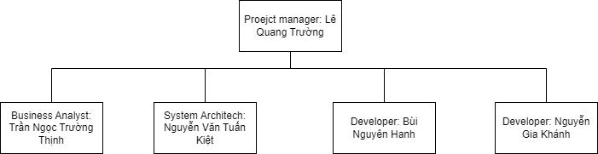

## **Roles and Responsibilities**

| **Person** | **Role** |
| --- | --- |
| Lê Quang Trường, Project Manager and Software Engineer | Write project plan (including assign tasks) Monitor and report status (weekly report) Coordinate meetings Contact point for the project |
| Trần Ngọc Trường Thịnh, Business Analyst and Software Engineer | Document requirements (interview customers, etc.)  Communicate with team members about the requirements  Coordinate to review requirements |
| Nguyễn Văn Tuấn Kiệt, Software Engineer and Architech | Design the system (components, classes, databases, etc.)  Design user interface  Create Software Architecture Document |
| Bùi Nguyên Hanh, Software Engineer and tester  Nguyễn Gia Khánh, Software Engineer and tester | Write source code  Perform unit test Review source code  Write test plan and test cases  Perform system test |

# **Management Process**

## **Project Estimates**

The Inception phase of this project will take 2 weeks. Initial estimates of subsequent phases can be seen in section 4.2.3 below.

## **Project Plan**

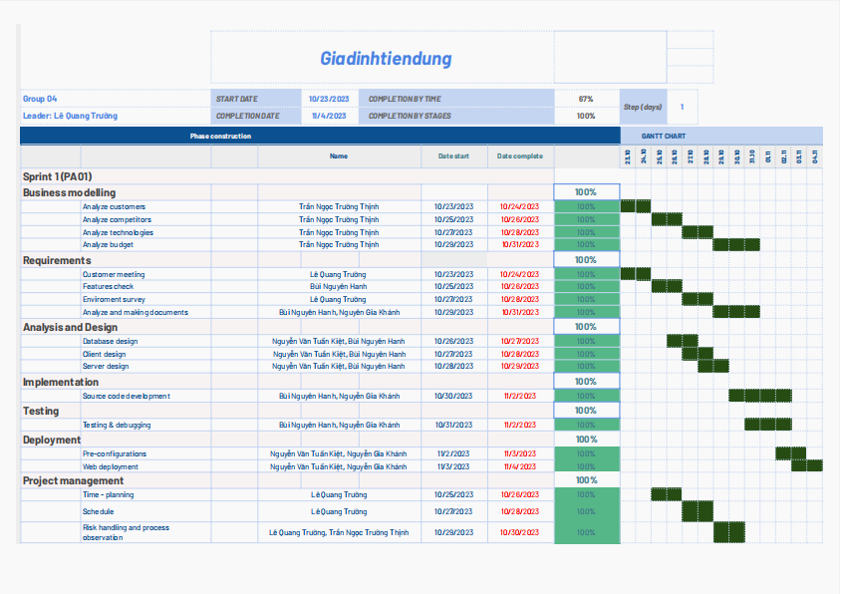

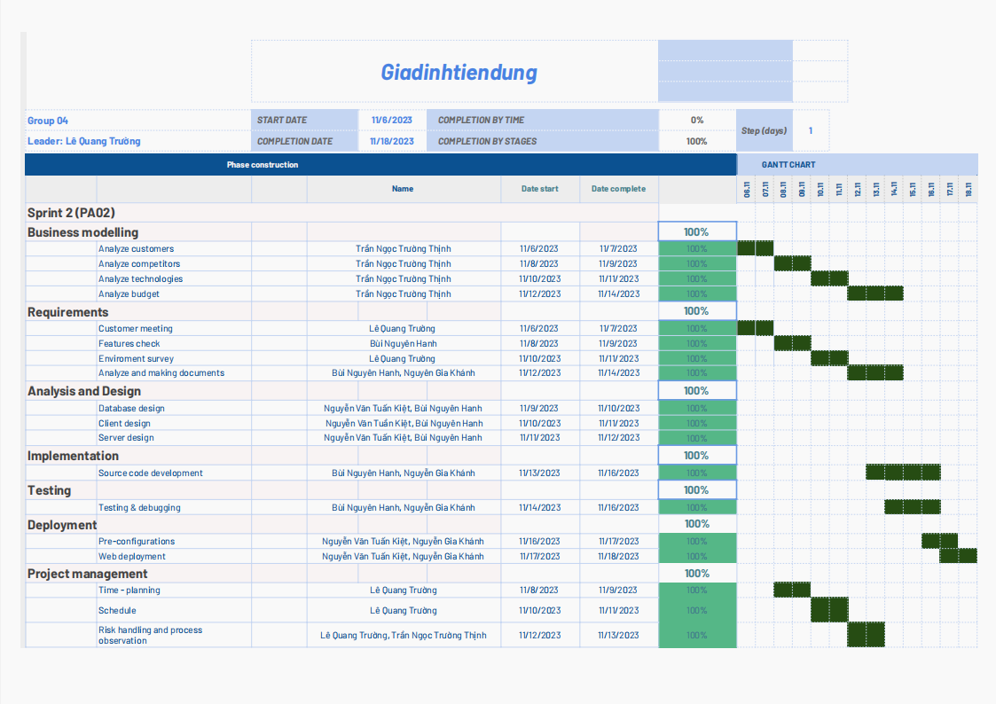

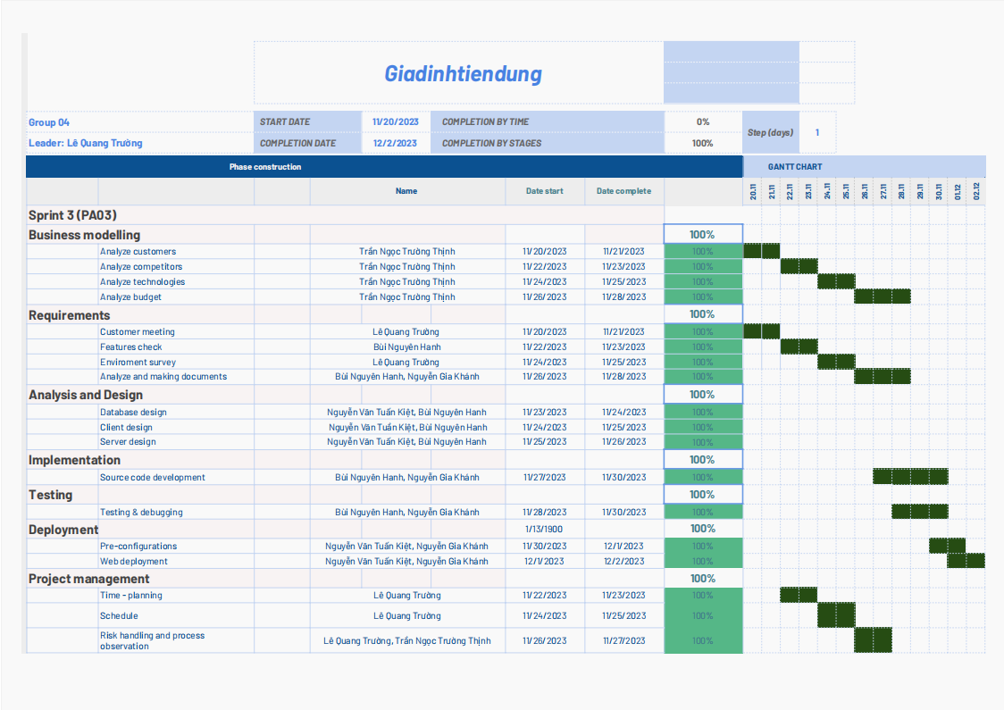

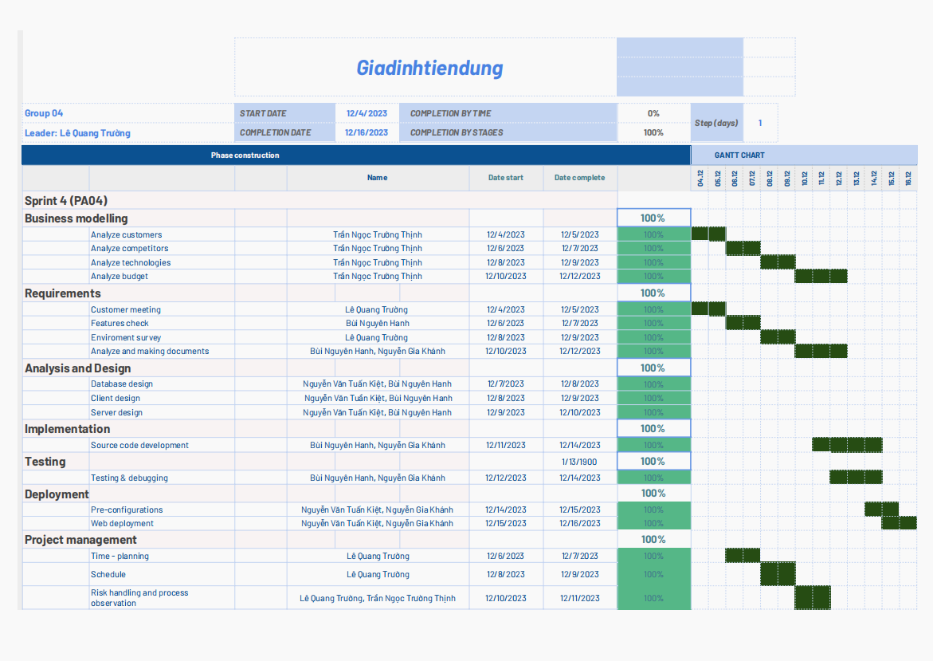

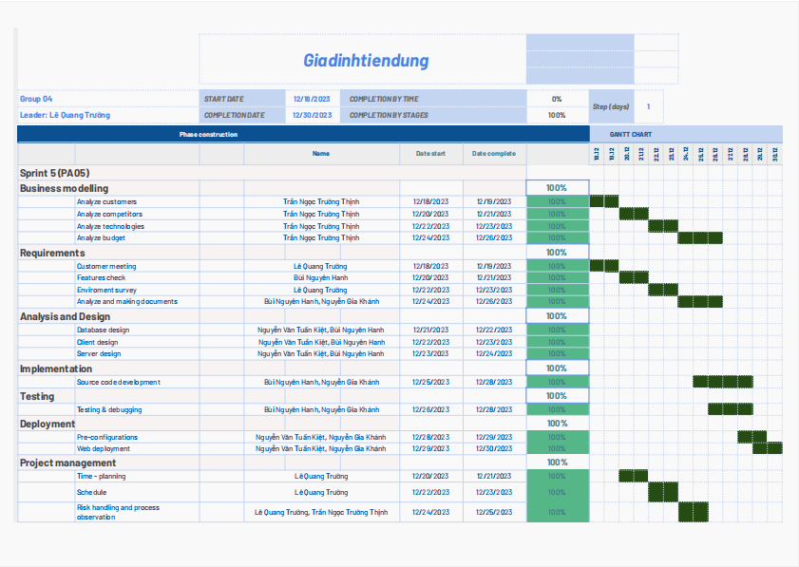

## **Project Monitoring and Control**

### *Requirements Management*

The requirements for this system are captured in the Vision document. Requested changes to requirements are captured in Change Requests, and are approved as part of the Configuration Management process.

### *Reporting and Measurement*

Updated cost and schedule estimates, and metrics summary reports, will be generated at the end of each iteration.

The Minimal Set of Metrics, as described in the RUP Guidelines: Metrics, will be gathered on a weekly basis. These include:

Earned value for completed tasks. This is used to re-estimate the schedule and budget for the remainder of the project, and/or to identify need for scope changes.

Total defects open and closed – shown as a trend graph. This is used to help estimate the effort remaining to correct defects.

Acceptance test cases passing – shown as a trend graph. This is used to demonstrate progress to stakeholders.

In addition, overall costs will be monitored against the project budget.

### *Risk Management*

Risks will be identified in Inception Phase using the steps identified in the RUP for Small Projects activity “Identify and Assess Risks”. Project risk is evaluated at least once per iteration and documented in this table. The risks of the greatest magnitude are listed first in the table.

| **Risk Ranking (High, Medium, Low)** | **Risk Description and Impact** | **Mitigation Strategy and/or Contingency Plan** |
| --- | --- | --- |
| Medium | A team member is sick or injured which takes time to recover before getting back to work | 2 other team members will take up the work of the person that is currently absence |
| Low | A team member drops out of the course entirely | 2 other team members will take up the work and the role of that person |
| High | A team member is busy with a deadline in another course and can not focus on his task in the time being | 2 other team members will take up the work of the person that is currently absence |
| High | Employees lack of Skills and Knowledge | Ensure that the development team is adequately trained and possesses the required skills. Consider hiring personnel with appropriate skills and utilize a continuous learning and training model. |
| Medium | Conflict among team members can disrupt work performance and affect product quality | Foster a positive working environment, promote effective communication, and address conflicts promptly. Establish conflict resolution guidelines and provide solutions when conflicts arise. |
| High | Software development projects may exceed the planned budget due to uncontrollable factors such as increased requirements or changes during development. | Execute careful budgeting and closely manage project finances. Establish regular expenditure monitoring.  Allocate contingency resources for situations where the budget exceeds the planned amount and predefine how to adjust the budget. |

### *Configuration Management*

Appropriate tools will be selected which provide a database of Change Requests and a controlled versioned repository of project artifacts.

All source code, test scripts, and data files are included in baselines. Documentation related to the source code is also included in the baseline, such as design documentation. All customer deliverable artifacts are included in the final baseline of the iteration, including executables.